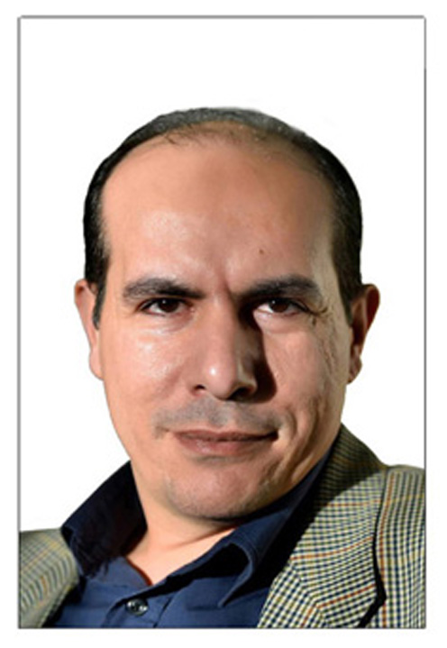
C.V.
I was born in 1973. I graduated from the faculty of Commerce. I'm a freelance cartoonist. My cartoons published and exhibited in more than 30 countries. I won these prizes:
*selected prize at "The First International Caricature Portrait Festival 2018 Beijing, China
*The Best humor artist of the international best humor artist award 2017- CHINA
*Excellent Prize in International Cartoon Competition on Environmental Protection, 2017 China
* "Book Universe" Illustration Contest 2017, Spain
*Special Prize in Philosopher Wang Yangming Caricature & Ancient China Int. Competition & Exhibition- China 2017
*Special Prize in “Libo International Children Animation & Comics Festival 2017” - China
* HONOURABLE MENTION in 19th Porto Cartoon World Festival – Portugal 2017
* Best foreign cartoon in 15 Maya Kamath memorial Awards competition 2016, India.
* Best cartoon prize in 4^{th , 5th} and 6th International Cartoon Contest SICACO 2015 ,2016 and 2017. South Korea
*HONORARY MENTION in XXII "Humour a Gallarate"International Cartoon Contest- Italy 2016- Satire section.
*Third prize at Burdur Museum 30th National and 3rd International Cartoon Contest – Turkey 2015
*Bronze prize in 13th FreeCartoonsWeb International Cartoonet Festival - 2014
*First prize in 2nd CARTOON AFRICA INTERNATIONAL BIENNIAL (CAIB) -NIGERIA 2014
*CERTIFICATE OF ACHIEVEMENT AWARD in 16TH INTERNATIONAL SCIENCE AND SPRING FESTIVAL CARTOON COMPETITION- SULEYMAN DEMIREL UNIVERSITY (Turkey 2013)
*Bronze prize in 12th FreeCartoonsWeb International Cartoonet Festival - 2013
* Excellent Prize in 2013 University Cartoon Competition on Environmental Protection UCCEP (china)
* Honorable Mentions (2nd SEJONG, Daejeon, Seoul, Korea), 2013
* Gold prize in 10th FreeCartoonsWeb International Cartoonet Festival (China 2011)
* Grand prize 16° Salón Mercosur Internacional Diógenes Taborda (Caricature category) - Argentina 2011
* Best cartoon prize in 20th Daejeon International Cartoon Contest (DICACO 2011 – South Korea
* First prize in 6th Humor Hall of Limeira Sao Paulo – ( Interart category) – Brazil 2010
* Second prize in International “Naci Talat” Portrait Cartoon Exhibition – Cyprus 2010
*First prize in TALIDE caricature competition “just explain it simply – the financial crisis and poverty (Germany 2009)
* Honorable mention in The 18th and 19th Daejeon International Cartoon Contest (DICACO 2009 , 2010) – South Korea.
* Excellent prize in 7th Lm International Cartoon Contest (China 2008).
* Excellent prize in 2nd "red man" international cartoon humor competition (China 2008).
* Diploma in the International festival of Cartoon and Humorous Literature - Humor at Gura Humorului (Romania 2008, 2014, 2016,2017 and 2018).
* A honorable mention in The Fourth, Fifth & sixth Chinese Jiaxing International Cartoon Exhibition (China 2008, 2010 and 2012)
* The first winner in the poster competition (1997,1999) in EGYPT from UNFPA (united nations population fund).
* The first winner in 'the international day of ozone' in EGYPT (1995).
* A honorable mention in graphic in the Egyptian nation contest (1994).
* A honorable mention in Suzan Mubarak contest for children books drawing (1996)
EXHIBITIONS:
* Expo ‘Wonderful Wonder World 2017 and 2018 in Tokyo – Japan.
* Cartoon project: DOSE SATIRE for a HEALTHY DEMOCRACY, Osten, Macedonia 2017.
* The jubilee exhibition KARIKATURUM, Surgut Fine Arts Museum , Russia 2017
* The 1st International Cartoon and Caricature Exhibition -Caritoon Kochi 2017- India
* The Best Cartoons of Nippon - SAITAMA- Japan 215, 2016 and 2017.
* SECAC International Cartoon Exhibition, Semarang, Indonesia 2016.
* 9th International Eskisehir Cartoon Festival, Eskisehir, Turkey 2016.
* "Metrostages" First Cartooning Festival, Greece 2016.
* Exhibition.. 100 Years of CHAPLIN Films, India 2015.
* Exhibition “Freedom of the Press, the Right to Know” Armenia 2014.
* International Anti-Nuclear Cartoon Exhibition in Sinop, Turkey 2014.
* The International "8 March Women's Rights Day- Violence Against Women” Cartoon Exhibition Antalya -Turkey 2013
* 15th, 16th, 17th, 18th, 19th,20th ,21st and 22nd ANNUAL INTERNATIONAL GRAPHIC HUMOR exhibition- university of ALCALA- Spain 2008, 2009, 2010, 2011, 2012, 2013, 2014 2015 and 2018
* Exhibition of The International Cartoon and Comic Press - TRAVEL WITHOUT BORDERS - Italy 2008
* "Moscow Exhibition of cartoons on Human Rights" from "The Russian Foundation Rights and Justice" (Russia -February 2009).
* First International Cartoon Exhibition Mussel & Fish Kavarna 2009 – Bulgaria
* Cartoon exhibit commemorating Freedom of Expression Day- Portugal 2009
* 2nd, 3rd , 5th , 6th & 7th International Exhibition of Graphic Humor, Lima– Peru 2009, 2010, 2012 ,2013 ,2014 & 2015
* Sal de Humor do Litoral Paulista – Brazil 2009
* Exile International Cartoon Expo- Paris, France 2011

*Jury member of:
-The first International CAIROCATURE Cartoon Contest-Egypt/ 2018
- 2nd international Our Heritage Jerusalem cartoon contest. Turkey 2018
- The 14th International Cartoon Contest SYRIA 2018
- The Fine Arts Competition of 4th Arab Water Forum, Cairo 2017
*Others:
- Representative of UWC (Union of World Cartoonists) association in Egypt.
- Ambassador of the competition NASREDDIN HODJA , sponsored by the Association of Turkish cartoonists.

